PROFESSIONAL DIPLOMA IN SOFTWARE ENGINEERING
WEB PROGRAMMING I
H7DT
PROJECT DOCUMENTATION
2nd Home – Online Property Rental System
MALEESHA PRAMUD
[STUDENT ID]
COHORT [COHORT NUMBER]
<[BRANCH NAME] BRANCH>
Submission Date: [DD/MM/YYYY]

Content
1. Introduction
2. Requirement Analysis
3. Website Planning
4. User Interface Design
5. HTML and CSS Development
6. PHP Development
7. Database Design and Operation
8. XML Implementation
9. Multimedia and File upload
10. Error Handling and validation
11. Screenshot of the Web Application
12. Conclusion
Appendices

1. INTRODUCTION
2nd Home is an online property rental platform. Property owners (hosts) publish houses and rooms with photos, prices and amenities, and travellers (guests) search the listings, check which dates are free, pay securely online and receive e-mail confirmation of their stay. Before this system, hosts had to rely on phone calls, social media messages and handwritten calendars to take reservations, which was slow and caused double bookings.
This document explains how the 2nd Home web application was planned, designed and built. The system lets guests browse and search properties, save favourites, add stays to a booking cart, check out in one payment and review the places they stayed in. Hosts get their own dashboard to manage listings and see the bookings they received. A separate administrator area manages every property, category, amenity, user and booking on the site.
The application was developed with PHP 8.3, MySQL 8, HTML5 and CSS3. The interface is built with the Bootstrap 5 framework and the Inter font, and uses JavaScript (AJAX with JSON), jQuery, Owl Carousel, DataTables and the TinyMCE rich-text editor. Property data is also published as an XML feed with a DTD. Payments use the PayHere payment gateway (sandbox mode) and e-mails are sent with PHPMailer. The project runs inside Docker (php:8.3-apache) and is served on port 8080.

1.1 Assumptions
The following ideas were considered in the building of the system:
- The system runs on an Apache, PHP 8.x and MySQL 8 server (provided here by Docker containers).
- There are three kinds of account: Admin, Producer (Host) and Customer (Guest). Anyone can register as a guest or a host; administrator accounts are created directly in the database.
- A property can only be booked by one guest for any given night, so overlapping date ranges are rejected.
- All prices are in Sri Lankan Rupees (LKR). A 10% service fee is added to the nightly price total.
- Guests identify themselves with a Sri Lankan NIC and a Sri Lankan mobile number (07X XXXXXXX) when booking.
- Payments are handled by the PayHere sandbox; no real money is transferred.
- Property and category photos are uploaded to the assets/images/ folder on the server.
- Notification e-mails (welcome, password reset, booking confirmation and cancellation) are sent through a Gmail SMTP account.
- A guest can only review a property that they have booked, and only once.

2. Requirements Analysis

2.1 Type Of Users
User Type | Who They Are | Access Level
Guest (Customer) | Travellers who register to search, book and review properties | Normal User (user_type_id = 3)
Host (Producer) | Property owners who list and manage their own properties | Host Access (user_type_id = 2)
Administrator | 2nd Home staff who manage all data and users | Full Access (user_type_id = 1)
Visitor | Anyone who visits the site without logging in | Browse and search only

2.2 What Guests Need To Do
- Register an account (as a guest) and log in; reset a forgotten password by e-mail.
- Browse featured properties, newly added properties and property categories on the home page.
- Search by keyword and filter by category, maximum price and amenities.
- Open a property page to see its photo gallery, description, amenities, host and reviews.
- Check whether a property is available for chosen dates and number of guests.
- Save properties to a favourites list.
- Add several stays to a booking cart and pay for them together (multi-checkout), or book one stay directly.
- Pay online through PayHere and receive an e-mail confirmation.
- View, edit the details of, or cancel their own bookings.
- Write, edit and delete a review (rating 1–5 and comment) for a property they have booked.
- Update their profile details and change their password in Account Settings.

2.3 What Hosts Need To Do
- Register as a host (or upgrade from a guest account) and log in.
- View a dashboard with the number of own properties, bookings received and recent listings.
- Add a property with title, category, rich-text description, address, guests, bedrooms, beds, bathrooms, price, amenities and several photos.
- Edit or delete their properties, including removing and adding photos.
- Activate or deactivate a listing so that it appears or disappears on the site.
- View the bookings made on their own properties.

2.4 What Administrator Needs To Do
- Log in and open the admin dashboard to see summary numbers (properties, bookings, registered guests, hosts).
- View and manage every property on the site, and see every booking.
- Add, edit and delete property categories (with an image).
- Add, edit and delete amenities (with an icon).
- View all users, change a user’s type, activate or deactivate an account, or delete a user.

2.5 Other Requirements
Security: All input must be validated on the server, special characters must be controlled, protected pages must check the logged-in user and role, and prices must be calculated on the server and never trusted from the browser.
Easy to use: The website must work on PCs, tablets and phones, with a clean layout and clear messages.
Reliable: All forms are validated twice (in the browser and on the server) and show clear error notifications. A property can never be double booked.
Easy to maintain: Reusable files are used for the database connection, validation rules, e-mail sending, header/navigation, sidebars and footer.

3. Website Planning

3.1 Purpose Of The System
Guests should be able to find a place to stay, see instantly whether it is free on their dates and pay for it online. Hosts can publish and manage their properties without technical help, and the administrator keeps the platform organised. The system uses a live MySQL database instead of manual files, so listings, prices and availability are always up to date.

3.2 Page List and Navigation
Page Name | File | Who can see it
Home page | index.php | Everyone
Search / Category results | search.php | Everyone
Property details | single-property.php | Everyone
Confirm and pay | booking.php | Everyone
Sign Up | signup.php | Everyone
Sign In | signin.php | Everyone
Forgot / Reset Password | forgot-password.php  reset-password.php | Everyone
My Favorites | favorites.php | Everyone
Property XML feed | properties-feed.php | Everyone
My Cart | cart.php | Logged-in users
My Bookings | my-bookings.php | Logged-in users
Account Settings | account-settings.php | Logged-in users
Host Dashboard | producer/dashboard.php | Host only
Properties (list, add, edit) | listing/list.php  listing/add.php  listing/edit.php | Host / Admin
Manage Bookings | listing/bookings.php | Host / Admin
Admin Dashboard | admin/dashboard.php | Admin only
Categories | admin/category/list.php  add.php, edit.php | Admin only
Amenities | admin/amenity/list.php  add.php, edit.php | Admin only
User Management | admin/user-management.php | Admin only

3.3 Benefits of the New System
- All data is stored in a database, so there is no need for handwritten calendars or spreadsheets.
- Guests can search, check availability and book at any time, from any device.
- Double bookings are prevented automatically because the server checks for overlapping dates.
- Hosts can publish and update their listings immediately without involving an administrator.
- Confirmation e-mails are sent automatically to guests and hosts.
- The system can be expanded easily when new properties, categories and amenities are added.

4. User Interface Design

4.1 Design choices
- The navigation bar is created once (components/NavigationBar.php) and included on every public page. Dashboards use a shared sidebar component.
- A calm slate blue (#445D7B) is used for the logo, primary buttons and table headers on a very light grey background.
- Card-style boxes with soft shadows are used for properties, price details and statistics.
- The layout uses the Bootstrap grid and adjusts automatically to tablets and smartphones.
- Forms have clear labels, large input fields and error messages shown as red alert boxes or pop-up (toast) notifications.
- The navigation menu changes depending on who is logged in (guest, host, admin or visitor).

4.2 Color Scheme
Color Name | Hex Code | Where It Is Used
Slate Blue (primary) | #445D7B | Logo, buttons, links, table headers, active states
Page Background | #F9FAFB | Background of every page
Surface White | #FFFFFF | Cards, navigation bar, forms, sidebar
Dark Text | #1F2937 | Headings and body text
Gray Text | #6B7280 | Small labels, dates, captions
Border Gray | #E5E7EB | Card borders and dividers

4.3 Page Layout Description
Home Page
A full-width hero slider with three background photos has a headline and a search bar (destination, check-in and check-out). Below it are category tiles, a three-column grid of top-rated property cards, an amenities strip, a "Just added" list, a trust section, guest testimonials, a host call-to-action banner and the footer.
Search Page
A filter sidebar (price range and amenities) sits on the left and property cards fill the right. On phones the filters move into a slide-in panel opened by a Filters button.
Property Page
A photo gallery grid at the top, then host details, description and amenities on the left. A sticky booking card on the right takes the dates and number of guests. Reviews are listed at the bottom.
Confirm and Pay Page
A two-column page: the left column shows the trip details and the guest details form; the right column shows the property and a price breakdown (price × nights, service fee and total).
Dashboards
A fixed sidebar on the left links to the other management pages. Statistic cards and data tables (with search, sorting and paging) appear on the right.

5. HTML and CSS Development

5.1 HTML5 Elements Used
The site uses HTML5 semantic elements to make the page structure clear and readable.
HTML Element | Where It Is Used
<header> | Site header with the logo, search box and user menu (NavigationBar.php)
<nav> | Main navigation, user drop-down menu and breadcrumbs
<main> | The main content area of each page
<section> | Groups related content such as the hero slider on the home page
<aside> | Dashboard sidebars and the search filter sidebar
<footer> | Four-column footer with links and newsletter box (Footer.php)
<form> | Sign in, sign up, search, filters, booking, listing and settings forms
<table> | Admin and host data tables with <thead> and <tbody>
<input> / <select> / <textarea> | Form fields including date, number, file, checkbox and password inputs
<img> | Property photos, category images and the logo

Example: the header and navigation from components/NavigationBar.php:
<header class="main-header">
<div class="container">
<nav class="main-nav">
<a class="nav-brand" href="/index.php">
<img src="/assets/images/logo/logo-only-text.png" alt="2nd Home" style="height: 40px;">
</a>

<form action="/search.php" method="GET" class="nav-search">
<input type="text" name="q" placeholder="Search destinations, properties..." class="search-input">
<button type="submit" class="search-btn">Search</button>
</form>
...
</nav>
</div>
</header>
Code 5.1 – Semantic header, nav and form (components/NavigationBar.php)

5.2 External CSS Files
The styles are kept in external files inside assets/css/ and linked from components/head.php, so every page shares the same look. modern.css holds the global theme, navigation and cards; dashboard.css styles the admin and host dashboards; search.css, single-property.css and auth.css style the search page, property page and sign-in/sign-up pages. Bootstrap 5.3, Owl Carousel, DataTables and Bootstrap Icons are loaded as libraries. A few small inline styles are used for one-off layout tweaks (for example the hero slider on the home page).
<link rel="stylesheet" href="/assets/css/modern.css" />
<link rel="stylesheet" href="/assets/css/owl.carousel.min.css">
<link rel="stylesheet" href="/assets/css/owl.theme.default.min.css">
<link rel="stylesheet" href="https://cdn.jsdelivr.net/npm/bootstrap-icons@1.11.3/font/bootstrap-icons.min.css">
Code 5.2 – Stylesheets linked in components/head.php

5.3 CSS Features Used
CSS Variables (Custom Properties)
Variables hold the colours and common values at the top of modern.css, which makes it easy to change the theme in one place:
:root {
/* "Nordic Soft" Color Palette */
--primary-accent: #445d7b;
--background-color: #F9FAFB;
--surface-color: #FFFFFF;
--primary-text-color: #1F2937;
--secondary-text-color: #6B7280;
--border-color: #E5E7EB;

/* Font Weights */
--font-regular: 400;
--font-semibold: 600;
--font-bold: 700;

/* Other properties */
--border-radius: 0.5rem;
}
Code 5.3 – CSS variables (assets/css/modern.css)
Types of Selectors Used
- Element selectors: body, h1–h6, a
- Class selectors: .card, .btn-primary, .main-header, .property-card-modern, .stat-card, .dashboard-sidebar
- Pseudo classes: :hover (cards, buttons, links, dropdown menu), :focus (search input), :first-child and :not(:first-child) (gallery)
- Descendant selectors: .hero-slider .item, .nav-dropdown:hover .dropdown-menu
- Pseudo elements: .hero-slider .item::after (dark overlay on the slider photos)
Layout and Responsive Design
Flexbox is used for the navigation bar and dashboard layout, and CSS Grid is used for the property photo gallery and amenities list. Media queries (min-width: 768px, min-width: 992px and max-width: 575.98px) change the layout on small screens: the gallery shows one photo, the booking card becomes static, and the search filters move into a slide-in panel.
.image-gallery {
display: grid;
grid-template-columns: 2fr 1fr 1fr;
grid-template-rows: 1fr 1fr;
gap: 0.5rem;
height: 450px;
border-radius: 12px;
overflow: hidden;
}

/* on small screens */
.image-gallery {
grid-template-columns: 1fr;
grid-template-rows: 1fr;
height: 300px;
}
.gallery-item:not(:first-child) {
display: none;
}
Code 5.4 – CSS Grid gallery and its responsive rule (assets/css/single-property.css)

6. PHP Development

6.1 Variables
PHP variables store form data, query results and session data. Text input is trimmed and read with the null-coalescing operator so that missing fields never cause errors, and numeric values are validated before use:
// booking.php
$checkIn = $_GET['checkIn'] ?? '';
$checkOut = $_GET['checkOut'] ?? '';
$guests = $_GET['guests'] ?? '1';

// lib/add-listing-process.php
$title = trim($_POST['title'] ?? '');
$category = $_POST['category'] ?? '';
$description = trim($_POST['description'] ?? '');
$basePrice = $_POST['basePrice'] ?? '';
$amenities = isset($_POST['amenities']) && is_array($_POST['amenities']) ? $_POST['amenities'] : [];
Code 6.1 – Variables reading request data

6.2 Functions Used
Function | File | What It Does
session_start() | All pages and process files | Starts or resumes the user session
session_destroy() | logout.php | Ends the session when the user logs out
header() | Protected pages | Redirects users who are not allowed to see a page
trim() | All process files | Removes extra spaces from input
preg_match() | includes/validation.php | Checks names, mobile, email, NIC, numbers and text patterns
mb_strlen() | includes/validation.php | Checks text length limits
real_escape_string() | Database::escape() | Escapes special characters before values are used in SQL
htmlspecialchars() | NavigationBar.php, search.php, mailer.php | Stops script injection when printing user text
strip_tags() | Validation::sanitizeRichText() | Allows only simple formatting tags in descriptions
json_encode() | All lib/*-process.php files | Sends the result back to JavaScript as JSON
getimagesize() / is_uploaded_file() | Validation::validateImage() | Checks that an uploaded file is a real image
move_uploaded_file() | add-listing-process.php | Saves an uploaded photo to the server
uniqid() | Upload and order id code | Creates unique file names and order numbers
explode() / implode() | single-property.php, add-listing-process.php | Converts the image list between text and array
DOMDocument / createElement() | properties-feed.php | Builds and validates the XML feed
DateTime / diff() | Validation::getNights() | Validates dates and counts nights
date() | Pages with date inputs | Sets the earliest allowed date to today
md5() | checkout-process.php | Builds the PayHere payment hash
number_format() / round() | Booking and checkout code | Formats prices
unlink() | delete-listing-process.php | Deletes photo files when a property is removed
intval() | search.php, get-favorites-process.php | Forces IDs to integers

6.3 PHP Includes (Reusable Files)
Reusable files avoid copying the same code into every page. Every process file loads includes/connection.php, which in turn loads the validation and mailer classes; every page loads the shared components:
include './includes/connection.php'; // Database class + Validation + Mailer
include './components/head.php'; // <meta>, CSS links, page title
include './components/NavigationBar.php'; // header and navigation
include './components/Footer.php'; // footer
include './components/script.php'; // JavaScript libraries + toast container
Code 6.2 – Includes used by the pages
The dashboards include components/AdminSidebar.php or components/ProducerSidebar.php instead of the public navigation bar.

6.4 Forms and Data Transfer Between Pages
Forms send data with POST through small JavaScript helpers (AJAX). Values that identify a page, such as the property ID and the stay dates, travel between pages in the URL using GET:
// booking.php receives the property and stay details from the property page
if (isset($_GET['id']) && Validation::validateId($_GET['id'])) {
$propertyId = $_GET['id'];
} else {
header('location: /');
exit();
}

$checkIn = $_GET['checkIn'] ?? '';
$checkOut = $_GET['checkOut'] ?? '';
$guests = $_GET['guests'] ?? '1';
Code 6.3 – Reading GET values (booking.php)
function PostRequest(path, formData, callback) {
var req = new XMLHttpRequest();
req.onreadystatechange = function () {
if (req.readyState == 4) {
if (req.status === 200) {
var response = JSON.parse(req.responseText);
if (response.status) {
callback(response);
} else {
callback(null, response.message);
}
} else {
callback(null, 'Request failed with status: ' + req.status);
}
}
};
req.open('POST', path, true);
req.send(formData);
}
Code 6.4 – Sending form data with POST (assets/js/script.js)

6.5 Session Management
PHP sessions keep the user logged in while moving between pages. The e-mail address is stored in the session when the user signs in, and each protected page reads it to find the user and check their type:
// lib/signin-process.php – set at login
$_SESSION['email'] = $email;
$_SESSION['password'] = $password;

// producer/dashboard.php – check on a protected page
if (!isset($_SESSION['email'])) {
header('Location: /signin.php');
exit();
} else {
$email = $_SESSION['email'];
$userStmt = Database::search("SELECT * FROM `users` WHERE `email` = '$email'");
$userData = $userStmt->fetch_assoc();
if ($userData['user_type_id'] != 2) {
header('Location: /index.php');
exit();
}
}

// logout.php
session_start();
session_destroy();
Code 6.5 – Sessions: login, page protection and logout
Inactive accounts (status_id ≠ 1) are refused at sign in. When the user ticks "Remember Me", the e-mail and password are also stored in cookies for 30 days so the sign-in form is pre-filled; logging out removes these cookies.

7. Database Design and Operation

7.1 Database Tables
The database is named online_store and has ten tables:
Table Name | What It Stores | Important Columns
users | Guest, host and admin accounts | id, fname, lname, mobile, email, password, vcode, user_type_id, status_id
user_types | Account roles | id, name (Admin, Producer, Customer)
status | Active / Inactive flag | id, name
categories | Property categories | id, name, image
amenities | Available amenities | id, name, icon_cls
properties | Listed properties | id, title, categories_id, description, address, guests, bedrooms, beds, bathrooms, images, base_price, users_id, status_id
properties_has_amenities | Which amenities a property has | properties_id, amenities_id
bookings | Confirmed stays | id, checkIn, checkOut, first_name, last_name, nic, contact, guests, email, special_requests, properties_id, total_price, order_id
cart | Stays waiting to be checked out | id, users_id, properties_id, checkIn, checkOut, guests
reviews | Guest ratings and comments | id, properties_id, users_id, rating, comment, created_at

Relationships: properties belong to a category (categories_id) and a host (users_id); properties and amenities are linked many-to-many through properties_has_amenities; bookings, cart items and reviews each point to a property; reviews and cart items also point to a user and are removed automatically (ON DELETE CASCADE) when the property or user is deleted.

7.2 Connecting to the Database
A single Database class in includes/connection.php opens one shared MySQLi connection and offers helper methods for reading (search), writing (iud), escaping text and getting the last inserted id. (The host, user name and password are removed from the listing below.)
class Database {
public static $connection;

public static function setUpConnection() {
if (!isset(Database::$connection)) {
Database::$connection = new mysqli('host.docker.internal', 'root', '********', 'online_store', 3306);
}
}

public static function search($query) {
Database::setUpConnection();
$rs = Database::$connection->query($query);
return $rs;
}

public static function iud($query) {
Database::setUpConnection();
Database::$connection->query($query);
}

public static function escape($text) {
Database::setUpConnection();
return Database::$connection->real_escape_string($text);
}

public static function getInsertedId() {
return Database::$connection->insert_id;
}
}

require_once dirname(__FILE__) . '/validation.php';
require_once dirname(__FILE__) . '/mailer.php';
Code 7.1 – includes/connection.php

7.3 INSERT – Adding a Booking
After the input has been validated and the dates have been checked for overlap, the booking is saved. The total price is always calculated on the server:
// lib/booking-process.php
$calc = Validation::calculateBookingTotal($propertyId, $checkIn, $checkOut, $guests);
if (isset($calc['error'])) {
echo json_encode(['status' => false, 'message' => $calc['error']]);
exit();
}
$totalPrice = $calc['total'];

// Make sure the dates are still free
$overlap = Database::search("SELECT `id` FROM `bookings` WHERE `properties_id` = '$propertyId' AND `checkIn` < '$checkOut' AND `checkOut` > '$checkIn'");
if ($overlap && $overlap->num_rows > 0) {
echo json_encode(['status' => false, 'message' => 'This property is not available for the selected dates']);
exit();
}

// Insert the booking into the database
Database::iud("INSERT INTO `bookings` (`checkIn`,`checkOut`,`first_name`,`last_name`,`nic`,`contact`,`guests`,`email`,`special_requests`,`properties_id`,`total_price`,`order_id`) VALUES ('$checkIn','$checkOut','$firstName','$lastName','$nic','$contact','$guests','$email','$specialRequests','$propertyId','$totalPrice','$orderId')");
Code 7.2 – INSERT a booking (lib/booking-process.php)

7.4 SELECT – Featured Properties with Ratings
The home page joins properties with their reviews to show the average rating and the number of reviews of each active property:
// index.php
$propertiesStmt = Database::search("
SELECT p.*, AVG(r.rating) AS avg_rating, COUNT(r.id) AS review_count
FROM properties p
LEFT JOIN reviews r ON p.id = r.properties_id
WHERE p.status_id = 1
GROUP BY p.id
ORDER BY RAND()
LIMIT 6
");
Code 7.3 – SELECT with JOIN, GROUP BY and LIMIT (index.php)
The search page builds its WHERE clause from the chosen filters (keyword, category, maximum price and amenities):
// search.php
if (!empty($searchTerm)) {
$escapedSearch = Database::escape($searchTerm);
$conditions[] = "(p.title LIKE '%$escapedSearch%' OR p.address LIKE '%$escapedSearch%')";
}
if ($categoryId) {
$conditions[] = "p.categories_id = $categoryId";
}
$conditions[] = "p.status_id = 1";
...
if (!empty($conditions)) {
$query .= " WHERE " . implode(" AND ", $conditions);
}
Code 7.4 – Dynamic search query (search.php)

7.5 UPDATE – Editing a Profile
// lib/update-profile-process.php
if (!isset($_SESSION['email'])) {
echo json_encode(["status" => false, "message" => "Unauthorized access"]);
exit();
}
...
Database::iud("UPDATE `users` SET `fname` = '$fname', `lname` = '$lname', `mobile` = '$mobile' WHERE `email` = '$email'");

echo json_encode(["status" => true, "message" => "Profile updated successfully"]);
Code 7.5 – UPDATE the logged-in user’s profile

7.6 DELETE – Cancelling a Booking
Before deleting, the script confirms that the booking belongs to the logged-in guest, then sends a cancellation e-mail:
// lib/delete-booking-process.php
$id = Database::escape($_POST['id']);

// Security check: Ensure this booking belongs to the logged-in user
$email = $_SESSION['email'];
$checkStmt = Database::search("SELECT b.*, p.`title` FROM `bookings` b JOIN `properties` p ON b.`properties_id` = p.`id` WHERE b.`id` = '$id' AND b.`email` = '$email'");

if ($checkStmt->num_rows == 0) {
echo json_encode(['status' => false, 'message' => 'Unauthorized access']);
exit();
}
$booking = $checkStmt->fetch_assoc();

Database::iud("DELETE FROM `bookings` WHERE `id` = '$id'");

Mailer::sendBookingCancelled($booking['email'], $booking['first_name'], $booking['title'], $booking['checkIn'], $booking['checkOut']);
Code 7.6 – DELETE a booking

7.7 Security
- Every value that is placed in an SQL statement is escaped with Database::escape() (mysqli real_escape_string), and IDs are checked against a whole-number pattern (Validation::validateId) or cast to integers.
- All input is validated on the server by the Validation class, even if the browser has already checked it.
- Prices are never taken from the browser. The server calculates the total from the property price, number of nights and the 10% service fee, and the PayHere payment hash is generated on the server.
- Text printed back on a page (for example the search term and e-mail content) is passed through htmlspecialchars(), and rich-text property descriptions are cleaned so that only simple formatting tags without attributes remain.
- Uploaded files are checked to be real images before they are saved, and are stored under a random unique file name.
- Dashboards check the session and the user type, and booking edit/cancel actions check that the booking belongs to the logged-in user.
- Double booking is prevented by an overlap check on every booking and checkout.

8. XML Implementation
The property data of 2nd Home is also published as an XML document (properties-feed.php). This can be used by mobile apps, partner websites and other systems that need to read the 2nd Home listings. The rules of the XML document are defined in a DTD file (xml/properties.dtd), and the system can check that the generated XML follows these rules.

8.1 XML Structure Files
The feed lists every active property with its category, description, address, capacity, price, rating, amenities and photos. The data comes live from the database, so the XML is always up to date. Opening properties-feed.php shows all active properties, and properties-feed.php?id=5 shows a single property. Example output:
<?xml version="1.0" encoding="UTF-8"?>
<!DOCTYPE properties SYSTEM "/xml/properties.dtd">
<properties generated="2026-10-15" count="1">
<property id="5">
<title>Deluxe Room 1</title>
<category>Rooms</category>
<description>This is the description for deluxe room 1.</description>
<address>40/2, Rathnapura Road, Munagama, Horana</address>
<capacity guests="2" bedrooms="1" beds="1" bathrooms="1"/>
<price>200.00</price>
<rating reviews="0">0.0</rating>
<amenities>
<amenity>Wifi</amenity>
<amenity>Kitchen</amenity>
</amenities>
<images>
<image>/assets/images/properties/6a36b92a81a82.jpg</image>
</images>
</property>
</properties>
Code 8.1 – XML output of properties-feed.php?id=5 (shortened)
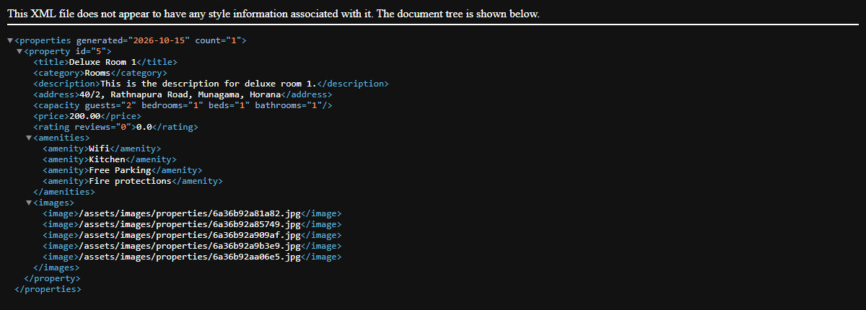
Figure 8.1 – XML feed shown in the browser (properties-feed.php?id=5)

8.2 Generating the XML with PHP
The feed is created with the PHP DOM extension (DOMDocument). The property rows are read from the database and each one is turned into XML elements and attributes. Text is added with createTextNode(), so special characters such as & and < are escaped automatically and the XML stays well-formed. The page is sent with the application/xml content type.
// properties-feed.php
$dom = new DOMDocument('1.0', 'UTF-8');
$dom->formatOutput = true;

$root = $dom->createElement('properties');
$root->setAttribute('generated', date('Y-m-d'));
$root->setAttribute('count', (string) $propertiesStmt->num_rows);
$dom->appendChild($root);

while ($row = $propertiesStmt->fetch_assoc()) {
$property = $dom->createElement('property');
$property->setAttribute('id', $row['id']);

addText($dom, $property, 'title', $row['title']);
addText($dom, $property, 'category', $row['category_name']);
addText($dom, $property, 'address', $row['address']);

$capacity = $dom->createElement('capacity');
$capacity->setAttribute('guests', $row['guests']);
$capacity->setAttribute('bedrooms', $row['bedrooms']);
$property->appendChild($capacity);
...
$root->appendChild($property);
}

header('Content-Type: application/xml; charset=UTF-8');
echo $xml;
Code 8.2 – Building the XML document (properties-feed.php)

8.3 Document Type Definition (DTD)
The DTD file lists which elements are allowed, in which order, and which attributes are required. The XML document points to it with the DOCTYPE line:
<!ELEMENT properties (property*)>
<!ATTLIST properties generated CDATA #REQUIRED
count CDATA #REQUIRED>

<!ELEMENT property (title, category, description, address, capacity, price, rating, amenities, images)>
<!ATTLIST property id CDATA #REQUIRED>

<!ELEMENT title (#PCDATA)>
<!ELEMENT category (#PCDATA)>
<!ELEMENT description (#PCDATA)>
<!ELEMENT address (#PCDATA)>

<!ELEMENT capacity EMPTY>
<!ATTLIST capacity guests CDATA #REQUIRED
bedrooms CDATA #REQUIRED
beds CDATA #REQUIRED
bathrooms CDATA #REQUIRED>

<!ELEMENT price (#PCDATA)>
<!ATTLIST price currency CDATA "LKR"
unit CDATA "night">

<!ELEMENT rating (#PCDATA)>
<!ATTLIST rating reviews CDATA #REQUIRED>

<!ELEMENT amenities (amenity*)>
<!ELEMENT amenity (#PCDATA)>

<!ELEMENT images (image*)>
<!ELEMENT image (#PCDATA)>
Code 8.3 – xml/properties.dtd

8.4 Validating the XML
Adding ?validate=1 to the feed address (properties-feed.php?validate=1) makes the page load the generated XML together with the DTD and run DOMDocument::validate(). It reports whether the document follows the rules, or lists the errors if it does not. For example, a property that is missing its <category> element is rejected.
// properties-feed.php?validate=1
$checkDom = new DOMDocument();
$checkDom->loadXML($checkXml, LIBXML_DTDLOAD);

if ($checkDom->validate()) {
echo "XML is valid against properties.dtd (" . $propertiesStmt->num_rows . " properties)";
} else {
echo "XML is NOT valid:\n";
foreach (libxml_get_errors() as $error) {
echo '- ' . trim($error->message) . "\n";
}
}
Code 8.4 – DTD validation
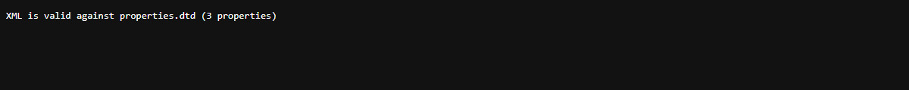
Figure 8.2 – Validation result (properties-feed.php?validate=1)

8.5 Why Use XML
- Other programs, such as mobile apps and partner websites, can read XML.
- It presents the listings in an orderly, readable form with a clear parent–child structure.
- The DTD guarantees that every mandatory field is present for each property record.
- It shows an alternative way of exchanging data outside the database and the website pages.
The AJAX requests between the pages and the server use the XMLHttpRequest object (see section 6.4) and exchange small JSON status messages such as {"status": true, "message": "..."}, because JSON is lighter for short replies. The site logo (assets/images/logo/logo_light.svg) is also an XML-based file (SVG). A Property XML feed link is available in the website footer.

9. Multimedia and File upload

9.1 Image Slider and Photo Gallery
The home page hero uses the Owl Carousel library to fade between three large background photos stored in assets/images/slider/. Every property page shows a photo gallery grid (one large photo and four smaller ones) with a "Show all photos" button that opens every uploaded image.
<section class="hero-section-modern">
<div class="owl-carousel hero-slider">
<div class="item" style="background-image: url('assets/images/slider/1.jpg');"></div>
<div class="item" style="background-image: url('assets/images/slider/2.jpeg');"></div>
...
</div>
</section>
Code 9.1 – Hero slider markup (index.php)

9.2 Property Photo Upload
Hosts can upload several photos when adding a property. The system checks every file before saving it:
Check | Rule
Upload error | The PHP upload error code must be UPLOAD_ERR_OK
File is a real upload | is_uploaded_file() must be true
File type | getimagesize() must succeed and the type must be JPEG, PNG, WebP or GIF
At least one image | A property cannot be saved without a photo

How the files are saved:
// lib/add-listing-process.php
foreach ($images['tmp_name'] as $key => $tmp_name) {
if ($images['error'][$key] !== UPLOAD_ERR_OK || !Validation::validateImage($tmp_name)) {
fail("Only valid image files (JPG, PNG, WEBP, GIF) are allowed");
}
}

// Save images to the images folder and keep the file names
$imagePaths = [];
foreach ($images['tmp_name'] as $key => $tmp_name) {
$name = uniqid() . ".jpg";
$path = $RootFilePath . "/../assets/images/properties/" . $name;
if (move_uploaded_file($tmp_name, $path)) {
$imagePaths[] = $name;
}
}
$imagePathsString = implode(',', $imagePaths);
Code 9.2 – Validating and saving property photos
// includes/validation.php
public static function validateImage($tmpName) {
if (!is_uploaded_file($tmpName)) return false;
$info = @getimagesize($tmpName);
return $info !== false && in_array($info[2], [IMAGETYPE_JPEG, IMAGETYPE_PNG, IMAGETYPE_WEBP, IMAGETYPE_GIF]);
}
Code 9.3 – Image validation (includes/validation.php)

9.3 Editing and Deleting Photos
When a host edits a property, the existing photos are shown and can be removed (the kept file names are sent in keptImages) and new photos can be added. When a property is deleted, its photo files are removed from the server with unlink(). Category pictures are uploaded and deleted in the same way and stored in assets/images/categories/.

10. Error Handling and validation

10.1 Form Validation Rules
Field | Rule | Page
First / Last name | Letters and spaces only, maximum 20 characters | Sign up, Profile, Booking
Mobile | Sri Lankan mobile format, e.g. 0771234567 (07X + 7 digits) | Sign up, Profile, Booking
Email | Must be a valid e-mail format | Sign in, Sign up, Booking
Password | At least 5 characters to sign up / sign in; at least 8 characters when resetting or changing | Sign up, Reset, Change password
Account type | Must choose Guest or Host | Sign up
NIC | 9 digits + V/X, or 12 digits | Booking
Check-in / Check-out | Valid dates, not in the past, check-out after check-in, maximum 365 nights | Property, Booking, Cart
Guests | Whole number from 1 up to the property’s maximum guests | Property, Booking
Special requests | Optional, maximum 500 characters, no special symbols | Booking
Review | Rating 1–5; comment required, maximum 1000 characters; booked guests only, one review per property | Property page
Property title / address | Required; title maximum 100, address maximum 255 characters | Add / Edit property
Description | Required rich text, maximum 5000 characters, safe characters only | Add / Edit property
Guests, bedrooms, beds, bathrooms | Whole numbers from 1 to 100 | Add / Edit property
Base price | Number greater than 0, up to 2 decimals | Add / Edit property
Photos | JPEG, PNG, WebP or GIF image files; at least one is required | Add / Edit property

10.2 How Errors Are Shown
Validation happens twice. First the browser checks the values with JavaScript regular expressions (RegexPatterns in script.js) and shows a message immediately. Then the server repeats the same checks with the Validation class, because browser checks can be bypassed. Server messages come back as JSON and are shown to the user either in a red alert box above the form (sign in and sign up) or in a pop-up toast notification (booking and management pages).
// includes/validation.php
const MOBILE_PATTERN = '/^07[0,1,2,4,5,6,7,8]{1}[0-9]{7}$/';
const NIC_PATTERN = '/^(?:[0-9]{9}[vVxX]|[0-9]{12})$/';

public static function validateMobile($mobile) {
return (bool) preg_match(self::MOBILE_PATTERN, $mobile);
}

// lib/signup-process.php
} else if (empty($fname)) {
echo ("First name is required");
} else if (!Validation::validateName($fname)) {
echo ("First name must contain only letters");
} else if (!Validation::validateMobile($mobile)) {
echo ("Mobile is not valid");
} else if (!Validation::validateEmail($email)) {
echo ("Email is not valid");
Code 10.1 – Server-side validation
// assets/js/script.js – client-side check before sending the booking
if (!nic) {
showToast("NIC is required.", 'warning');
return;
} else if (!RegexPatterns.nic.test(nic)) {
showToast("NIC is not valid.", 'warning');
return;
}
Code 10.2 – Client-side validation with toast notification

10.3 File Upload Errors
if ($images['error'][$key] !== UPLOAD_ERR_OK || !Validation::validateImage($tmp_name)) {
fail("Only valid image files (JPG, PNG, WEBP, GIF) are allowed");
}
...
if (empty($imagePaths)) {
fail("At least one image is required");
}
Code 10.3 – Upload error handling (lib/add-listing-process.php)

10.4 Business Rule Errors
// Dates already taken
if ($overlap && $overlap->num_rows > 0) {
echo json_encode(['status' => false, 'message' => 'This property is not available for the selected dates']);
exit();
}

// Only guests who booked may review
if ($bookingStmt->num_rows == 0) {
echo json_encode(['status' => false, 'message' => 'You can only review properties you have booked.']);
exit();
}
Code 10.4 – Availability and review rules

10.5 Page Access Control
If the user is not logged in, protected pages redirect to the sign-in page. If a logged-in user does not have the right role, they are sent back to the home page:
// Logged-in page protection (cart.php, my-bookings.php, account-settings.php)
if (!isset($_SESSION['email'])) {
header('Location: /signin.php');
exit();
}

// Admin page protection (admin/dashboard.php)
if ($userData['user_type_id'] != 1) {
header('Location: /index.php');
exit();
}
Code 10.5 – Page access control

11. Screenshots of the Web Application
All screenshots were taken from the running application (http://localhost:8080).

11.1 Home Page
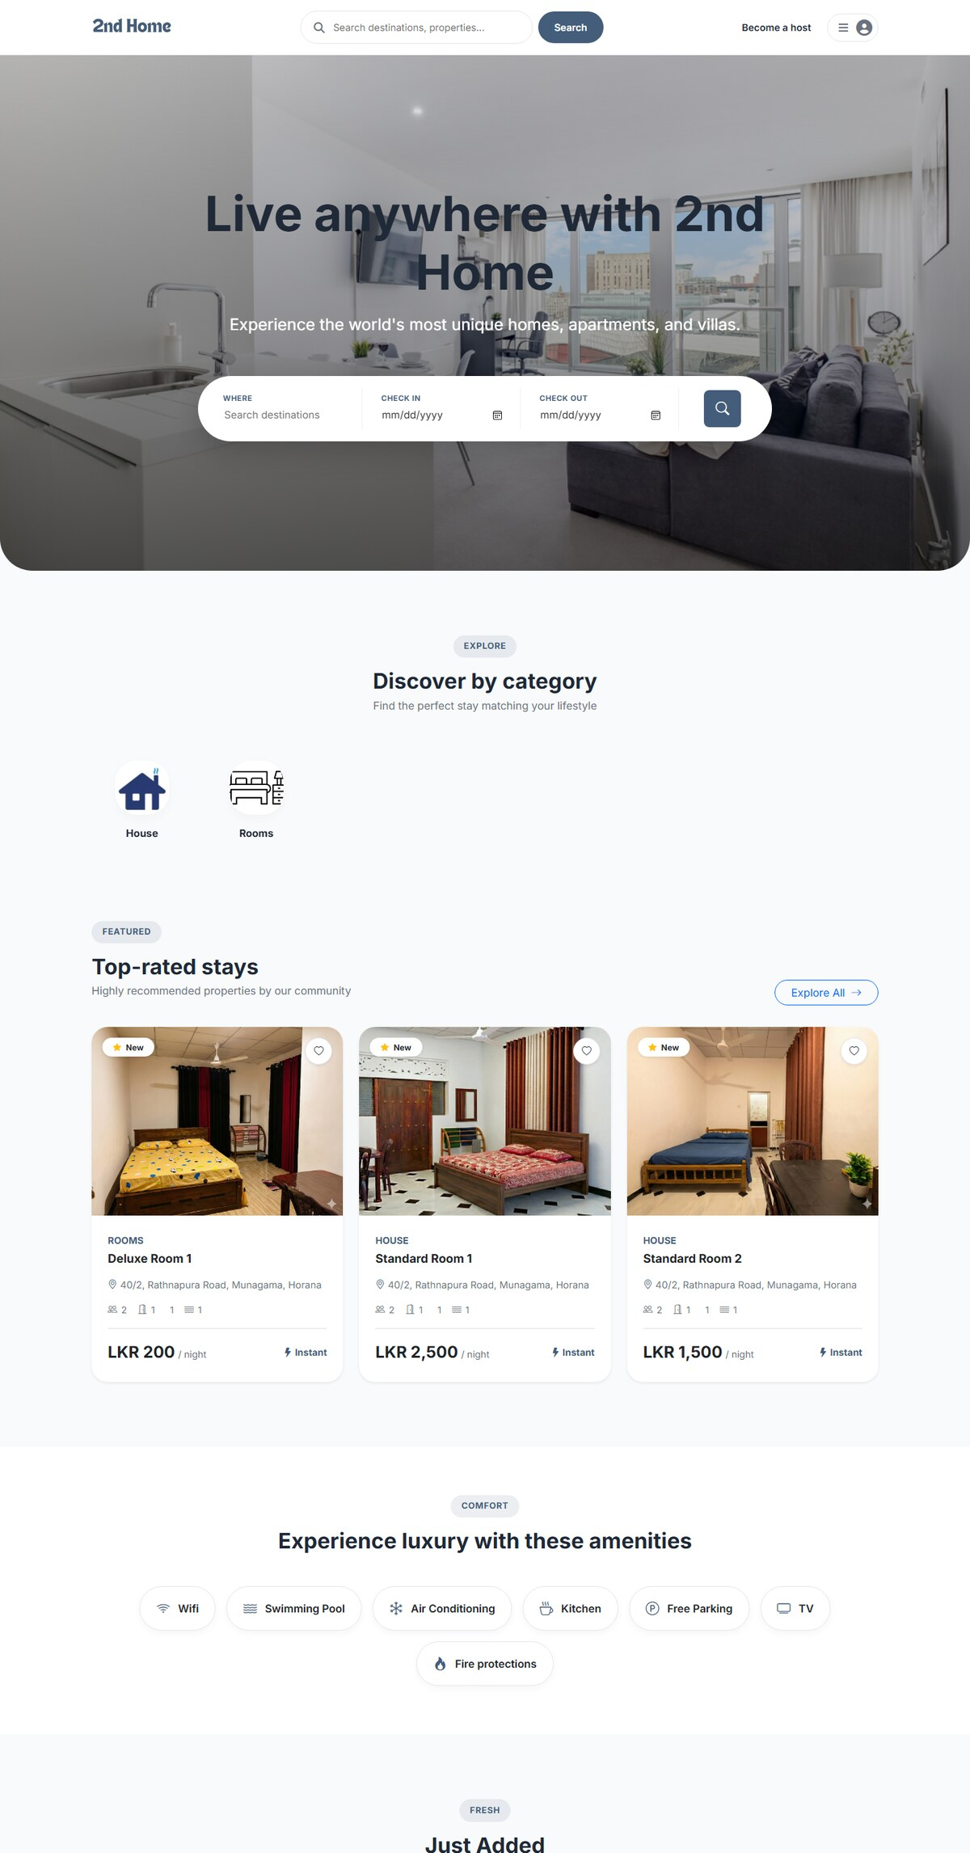
Figure 11.1 – Home page (hero slider, categories, featured and newest properties)

11.2 Search Results Page
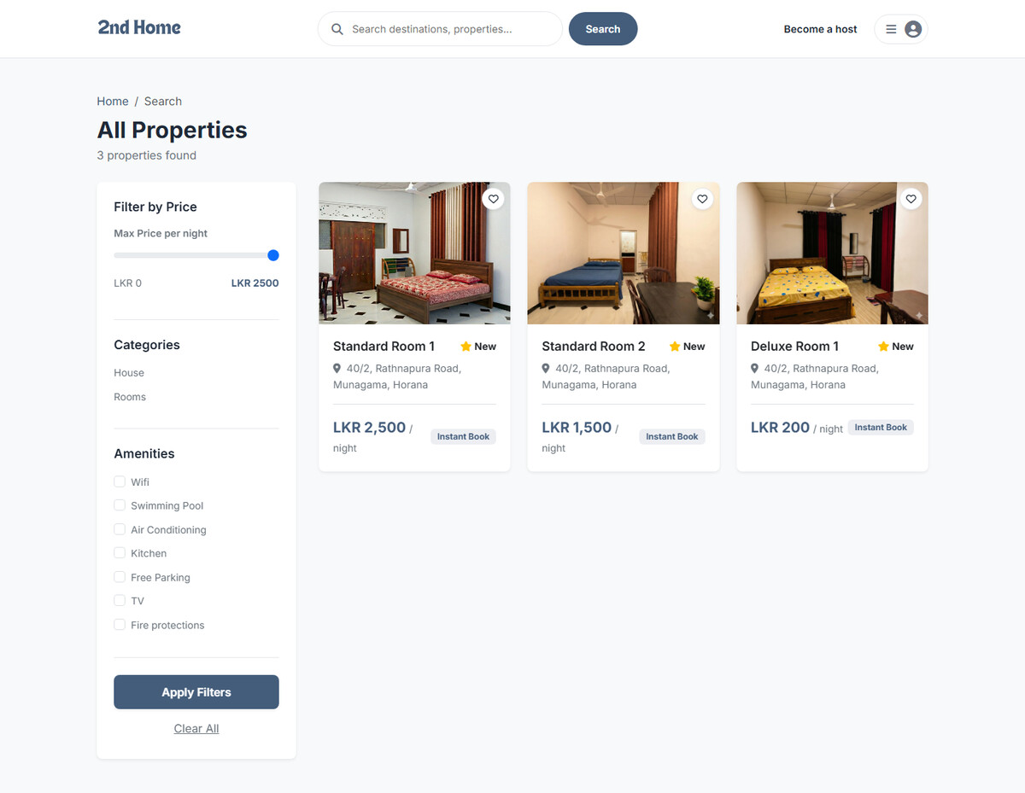
Figure 11.2 – Search page with filters and property cards

11.3 Property Details Page
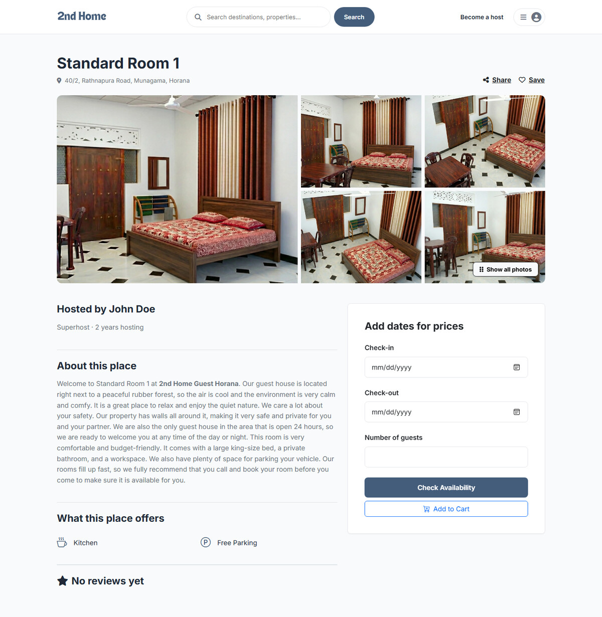
Figure 11.3 – Property page with gallery, amenities, reviews and booking card

11.4 Confirm and Pay Page
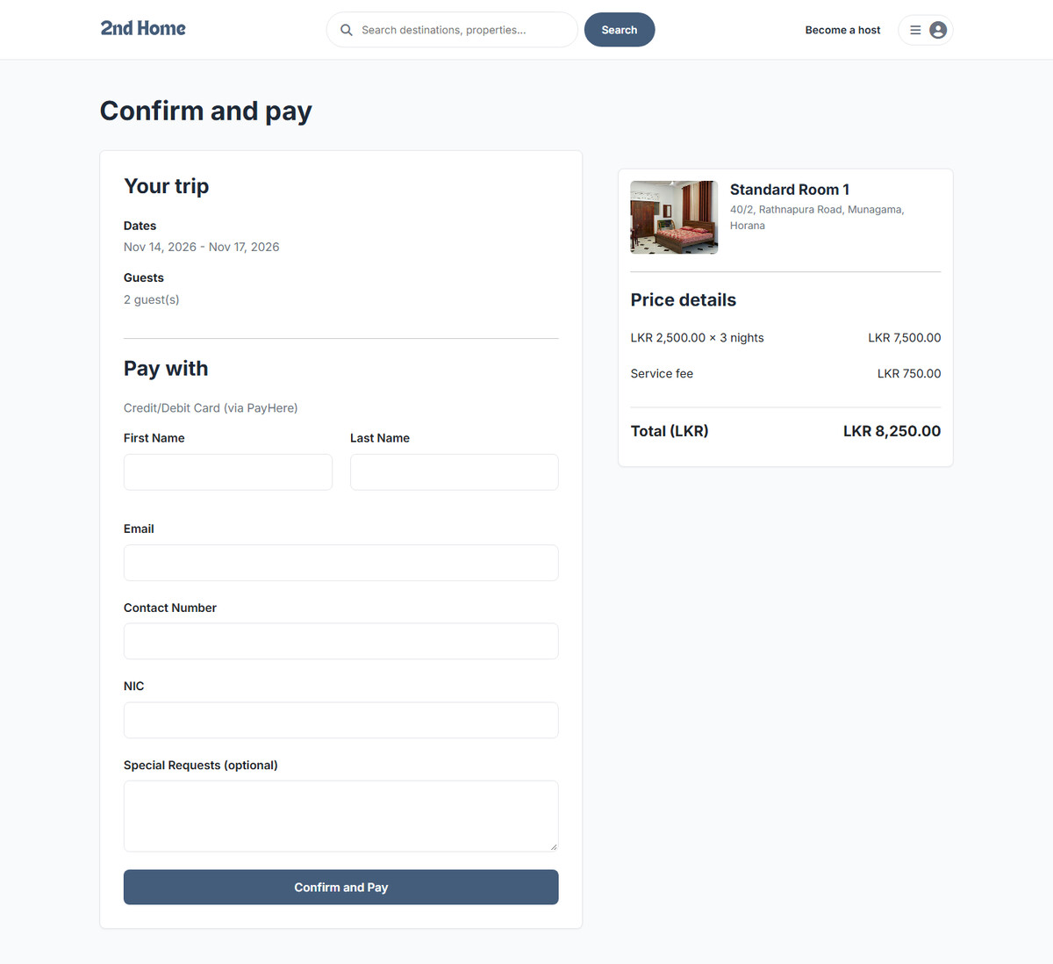
Figure 11.4 – Booking page with price breakdown (PayHere payment)

11.5 Sign Up Page
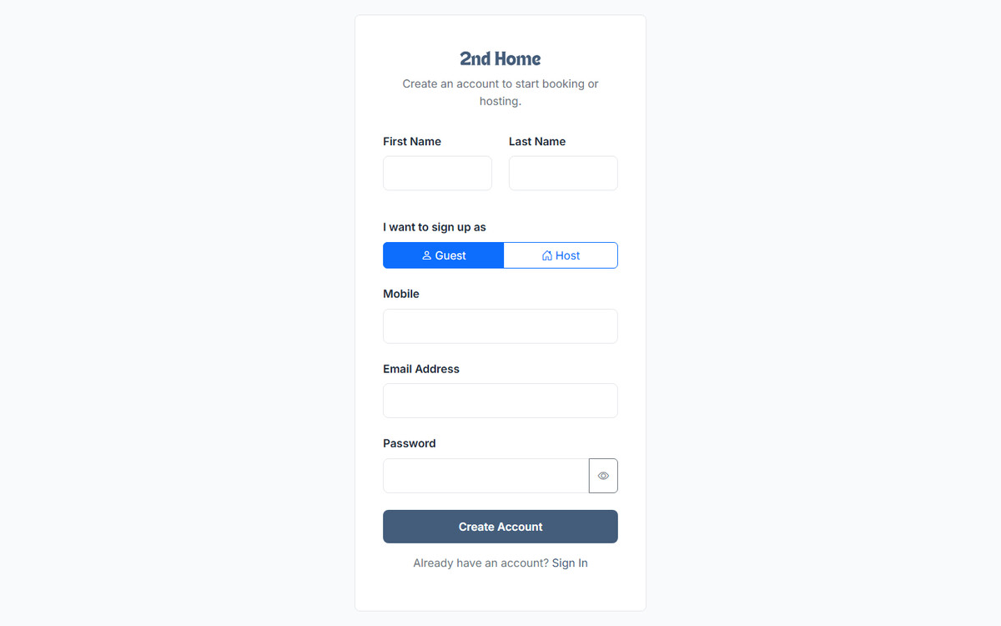
Figure 11.5 – Sign up page (guest or host)

11.6 Sign Up Validation Error
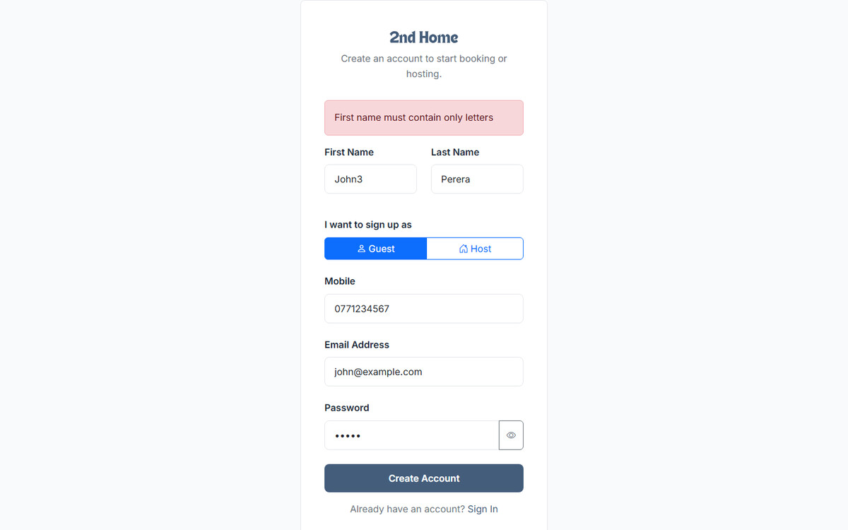
Figure 11.6 – Validation message on the sign up form

11.7 Sign In Page
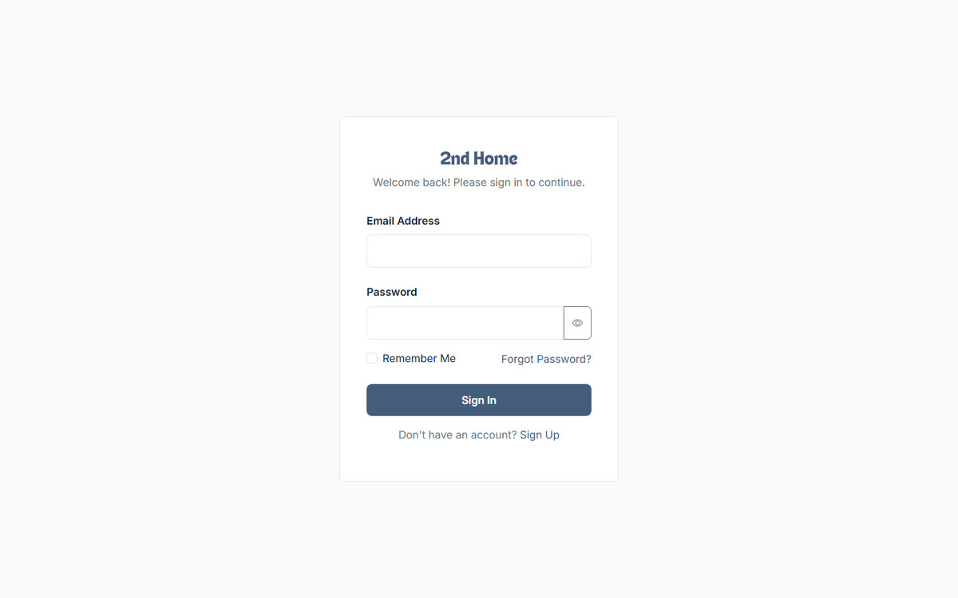
Figure 11.7 – Sign in page

11.8 Sign In Error Message
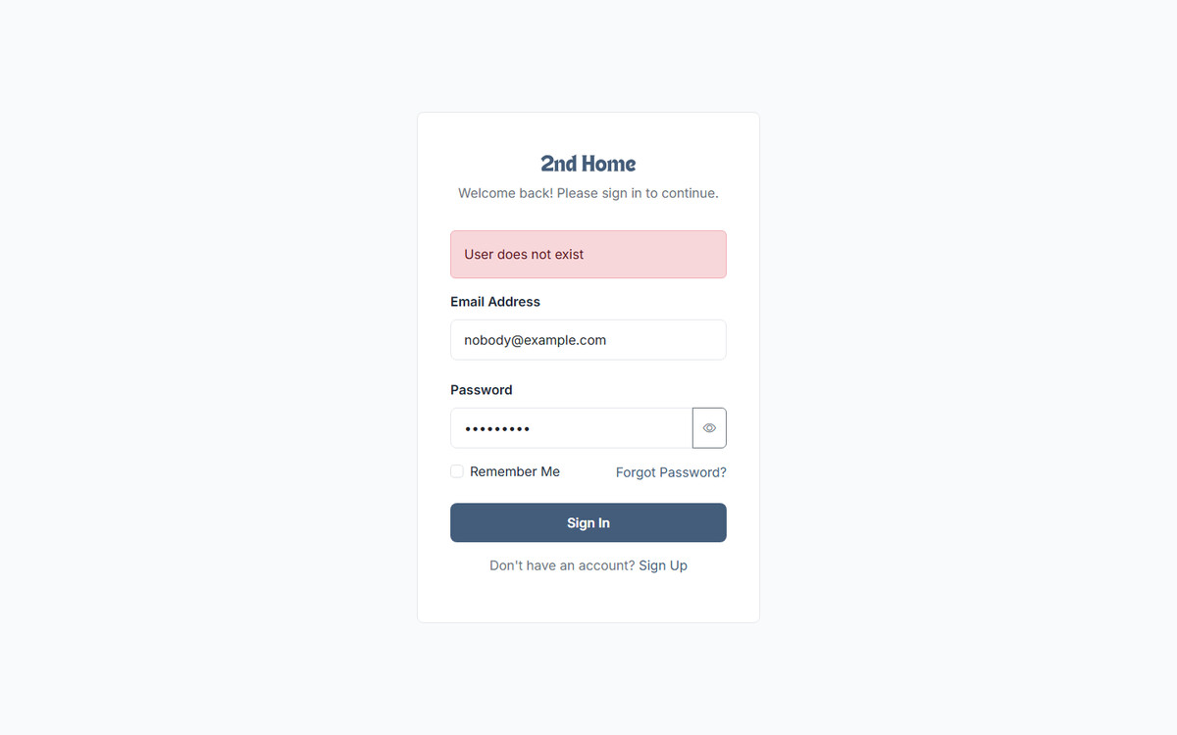
Figure 11.8 – Error shown for wrong login details

11.9 Forgot Password Page
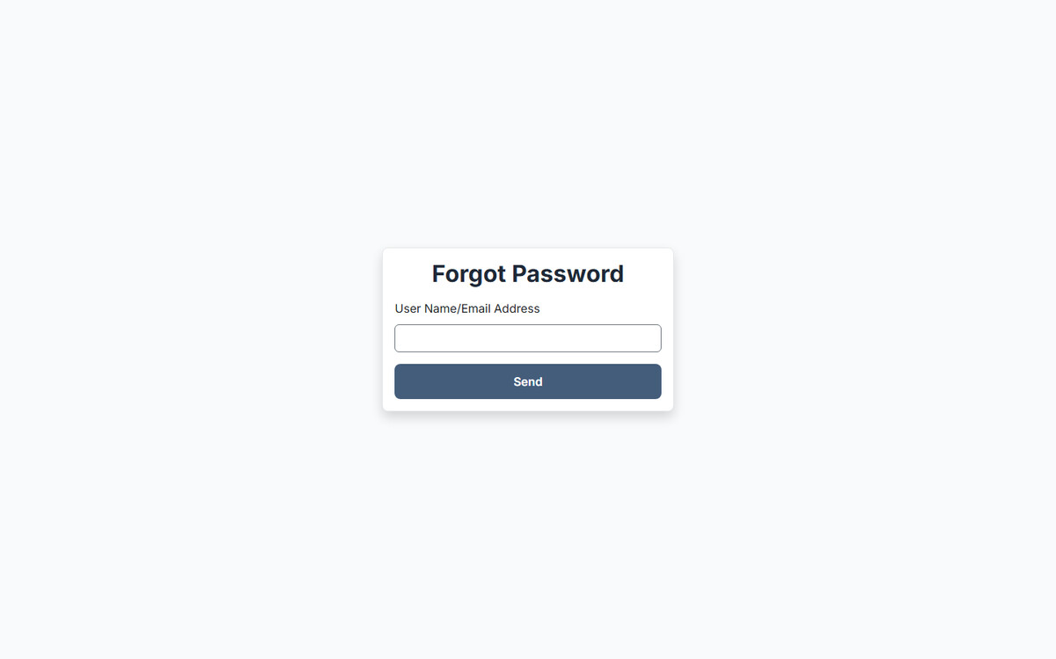
Figure 11.9 – Forgot password page

11.10 My Cart
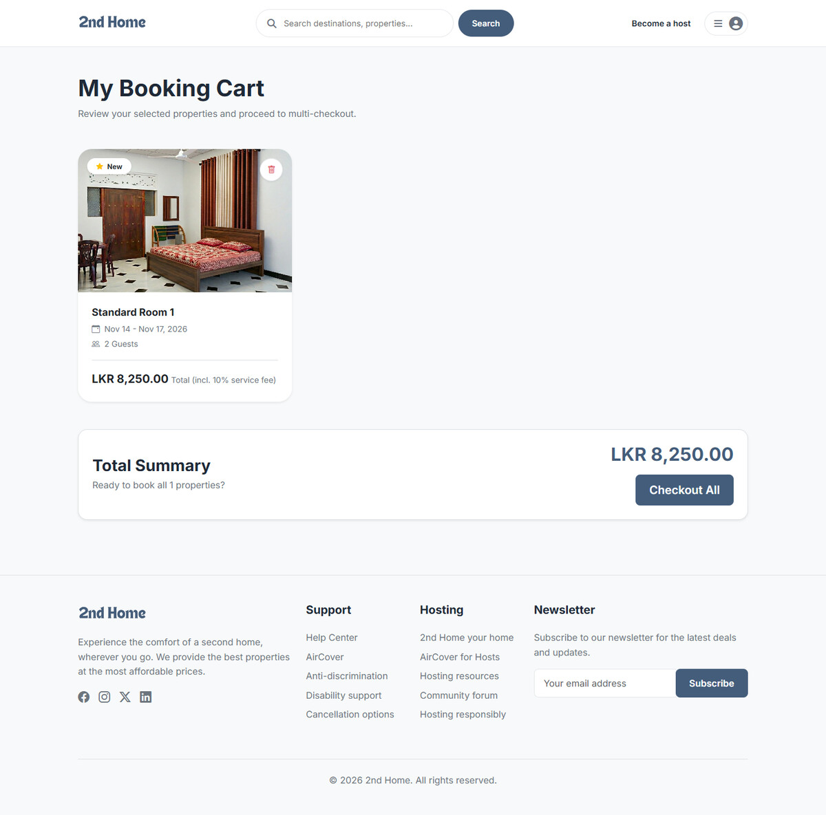
Figure 11.10 – Booking cart with multi-checkout

11.11 My Favorites
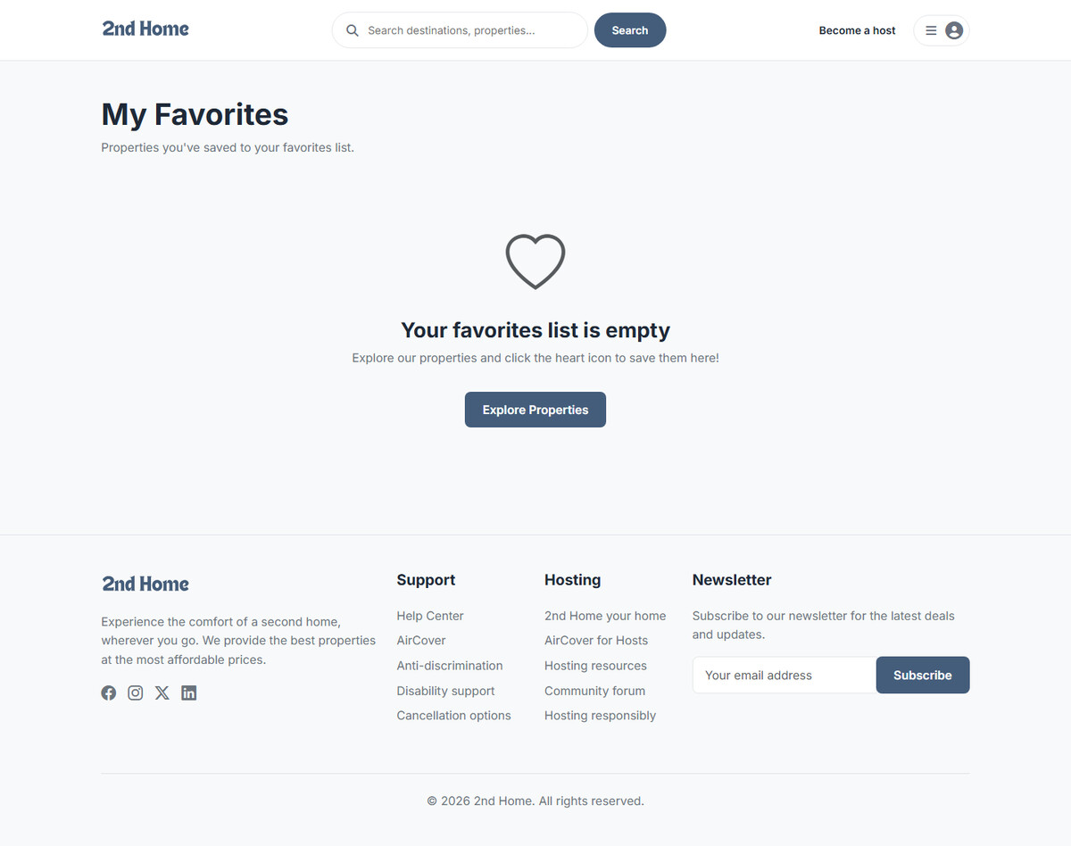
Figure 11.11 – Favorites page

11.12 My Bookings
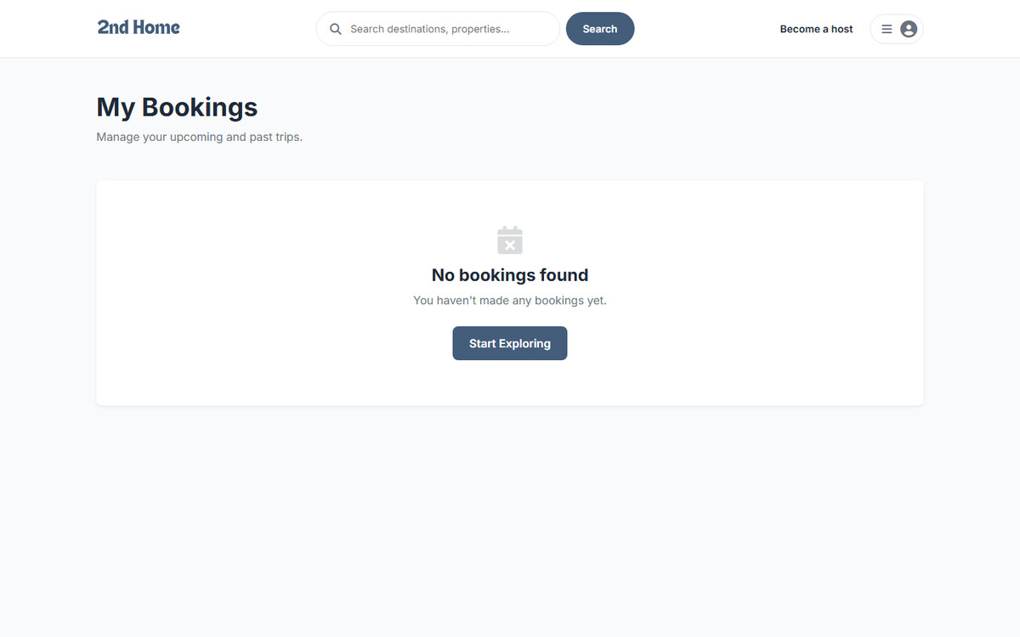
Figure 11.12 – My Bookings page (no bookings yet)

11.13 Account Settings
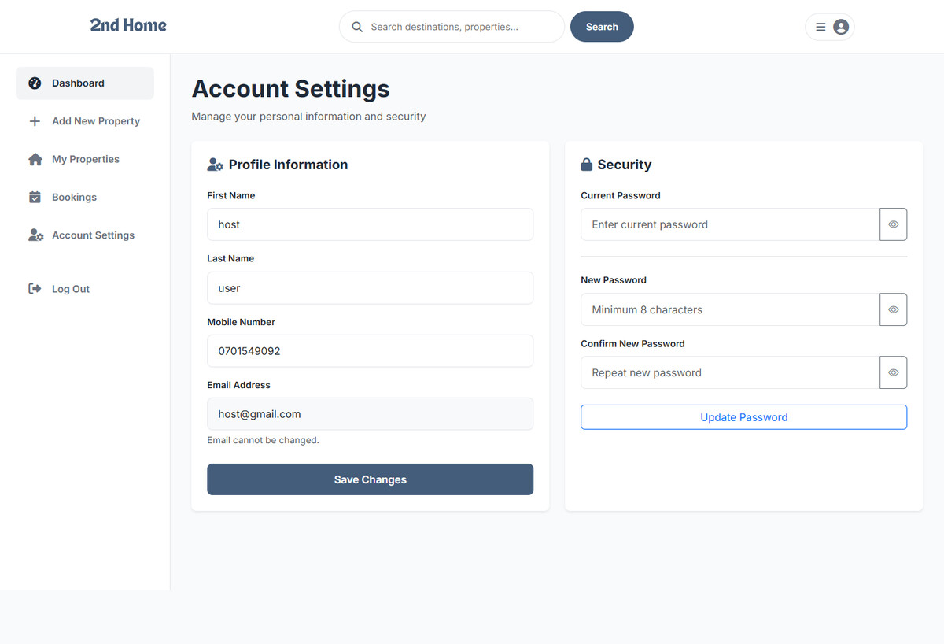
Figure 11.13 – Account settings (profile and password)

11.14 Host Dashboard
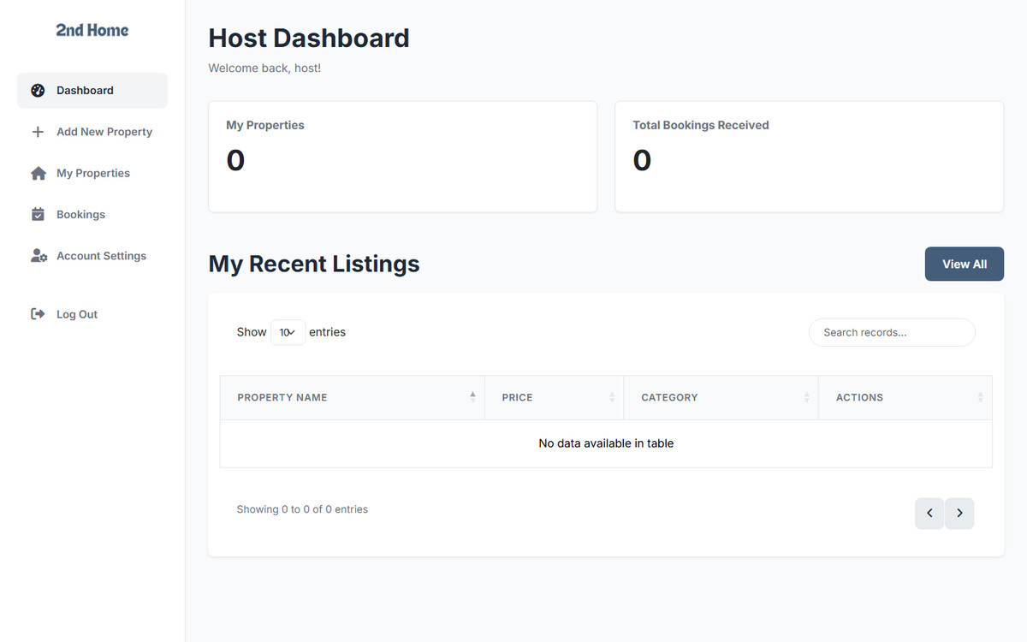
Figure 11.14 – Host dashboard

11.15 Host – My Properties
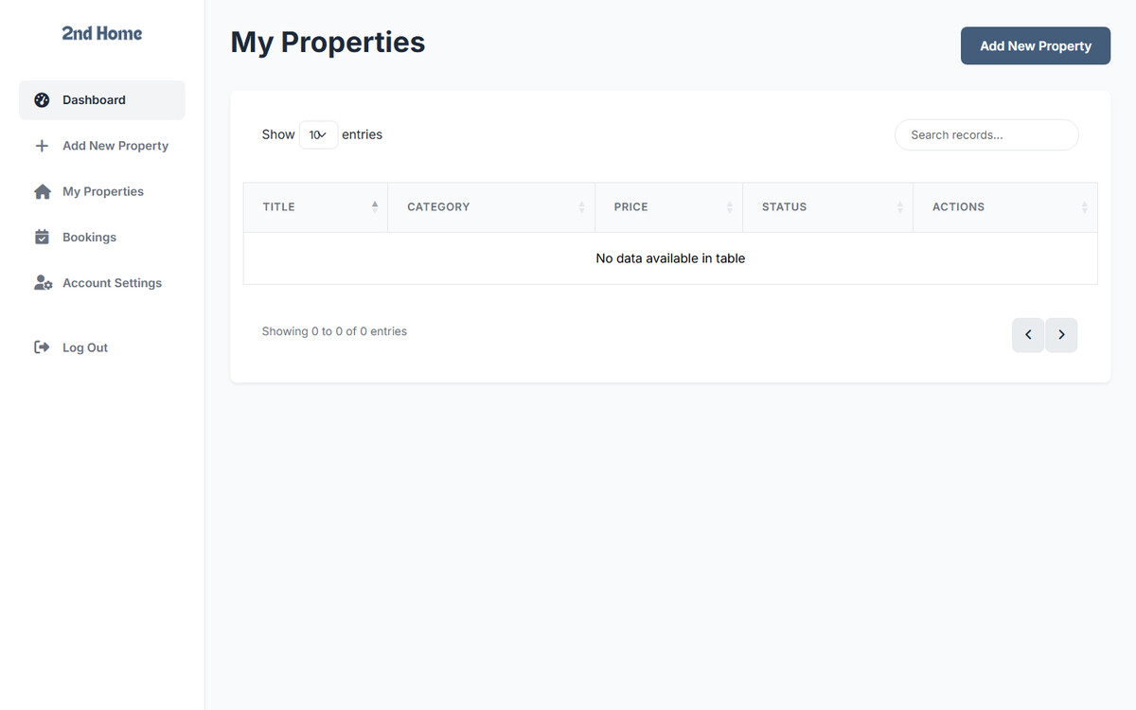
Figure 11.15 – Host property list

11.16 Host – Add New Property
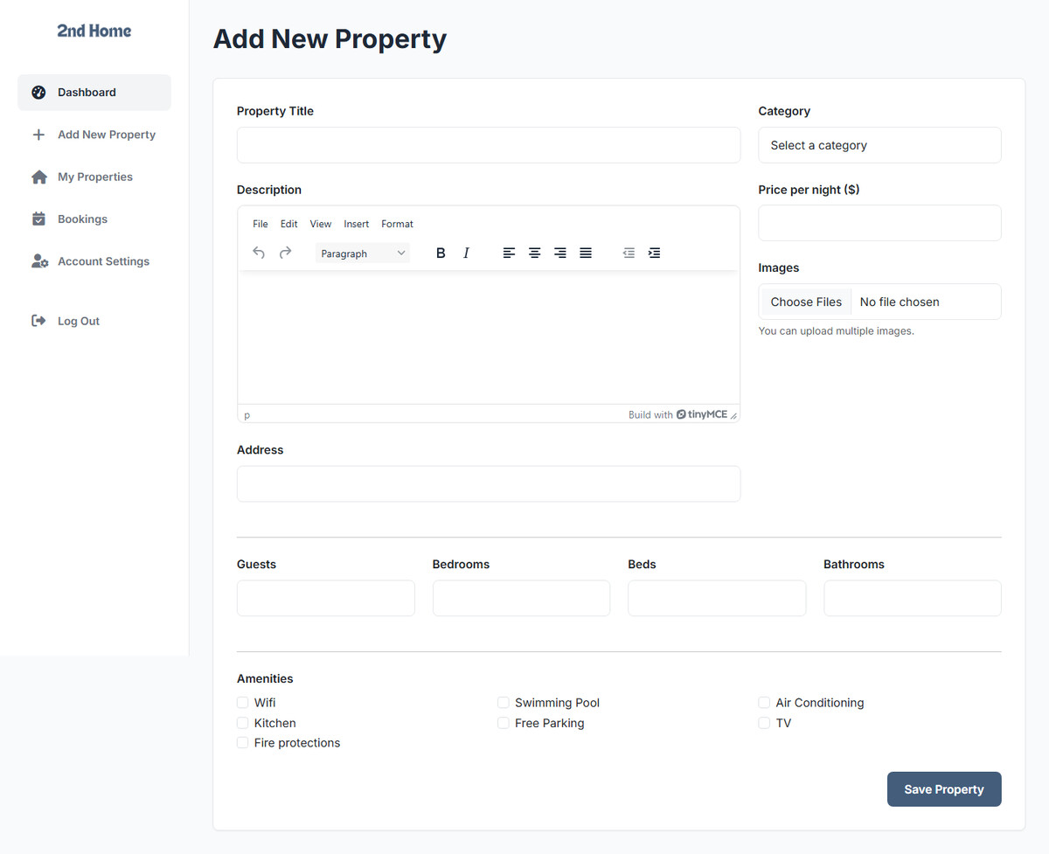
Figure 11.16 – Add property form with rich-text editor

11.17 Host – Bookings
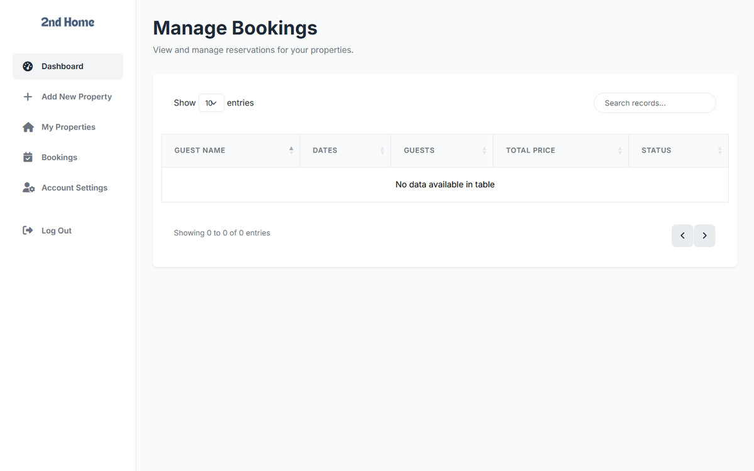
Figure 11.17 – Bookings received by the host

11.18 Admin Dashboard
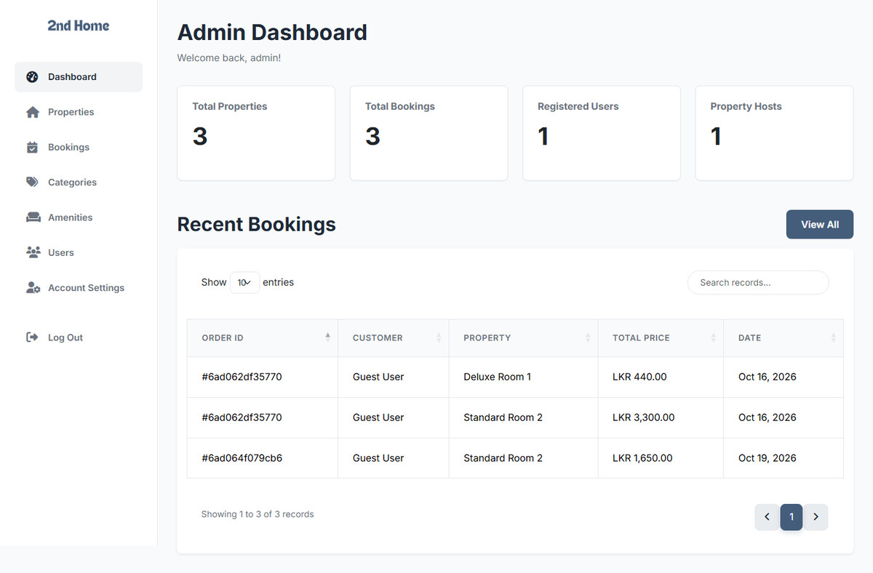
Figure 11.18 – Admin dashboard with summary statistics

11.19 Admin – Manage Properties
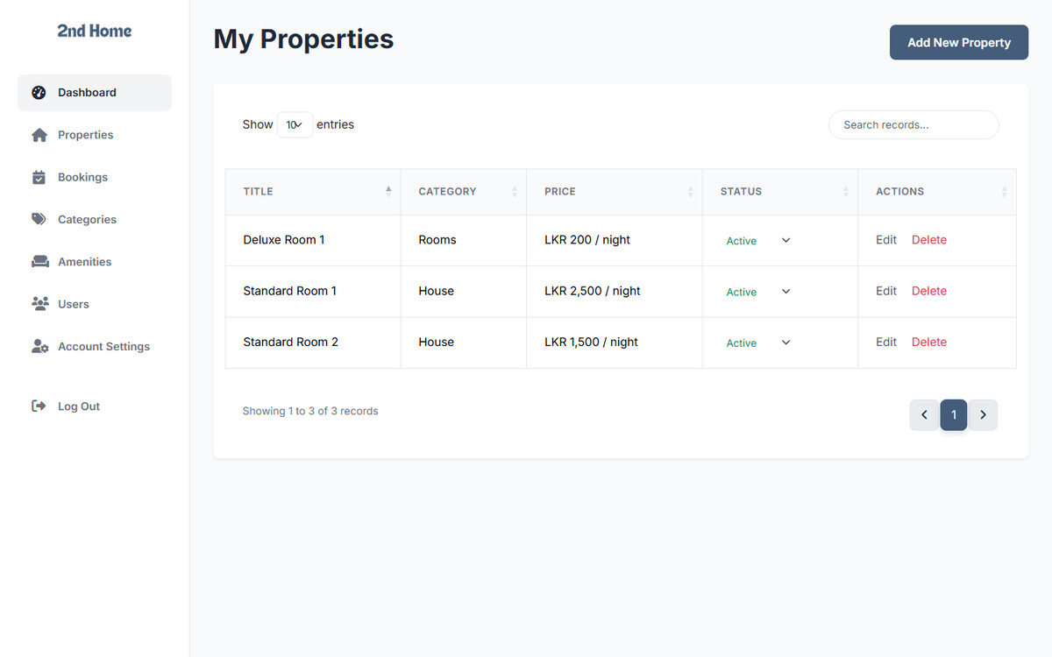
Figure 11.19 – Admin property list

11.20 Admin – Edit Property
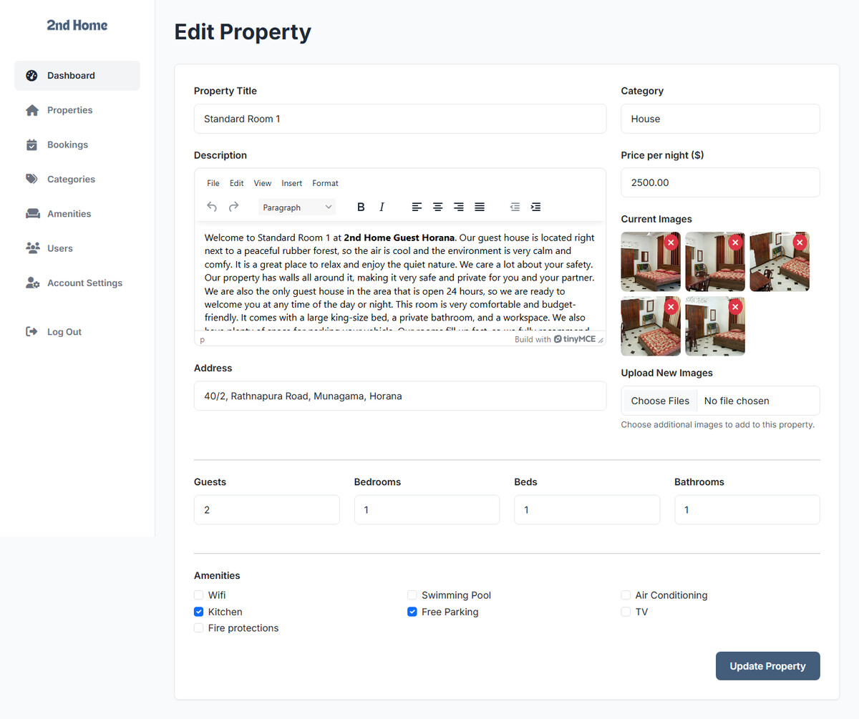
Figure 11.20 – Edit property form

11.21 Admin – Manage Bookings
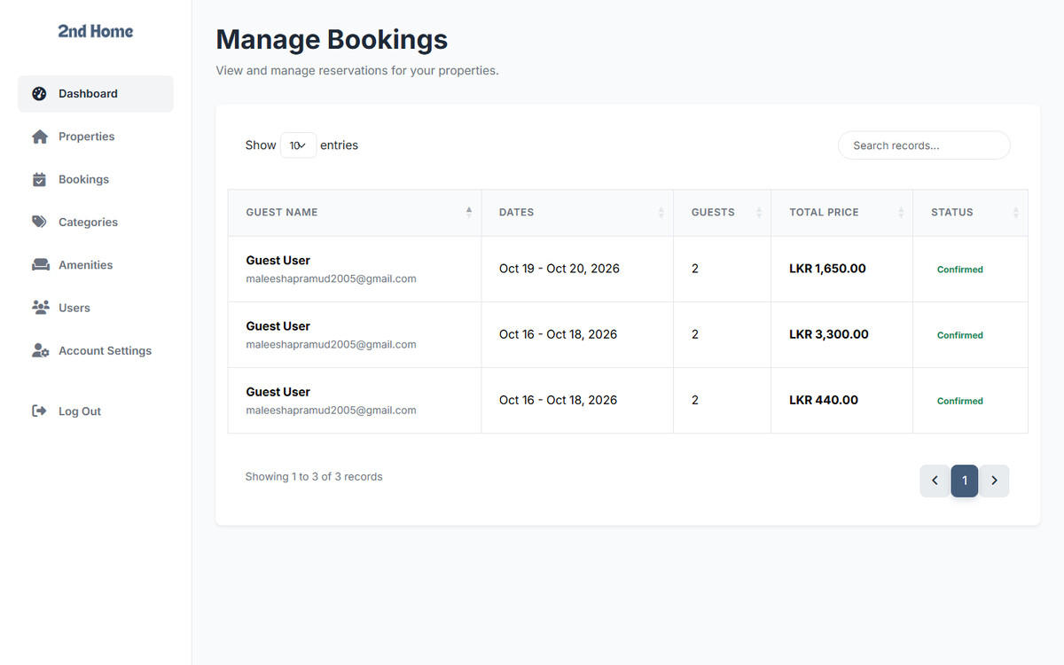
Figure 11.21 – All bookings

11.22 Admin – Categories
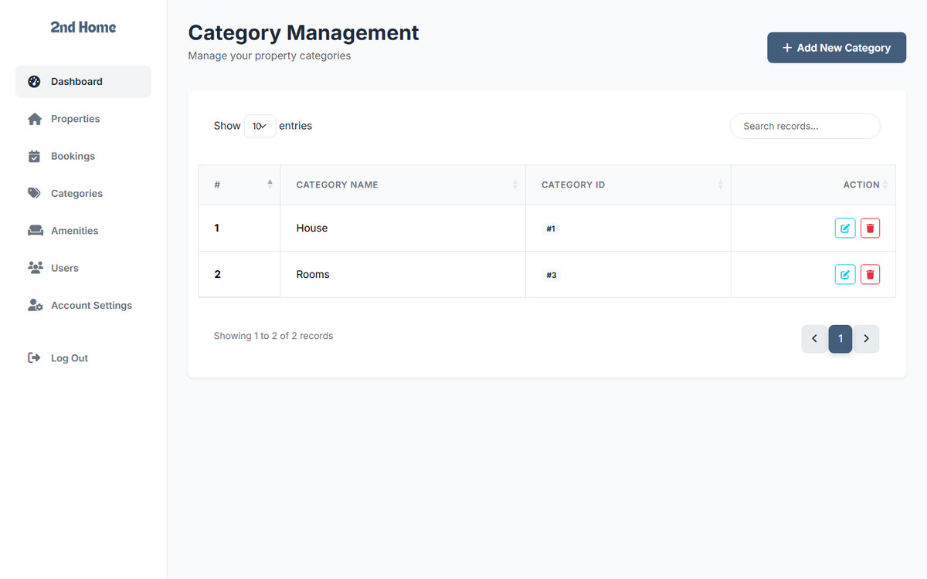
Figure 11.22 – Category list

11.23 Admin – Add Category
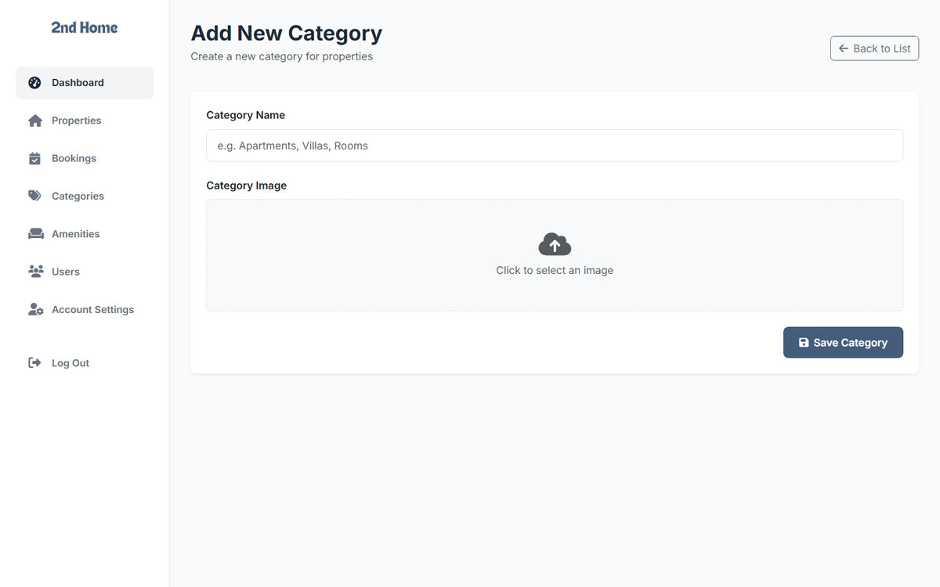
Figure 11.23 – Add category form

11.24 Admin – Amenities
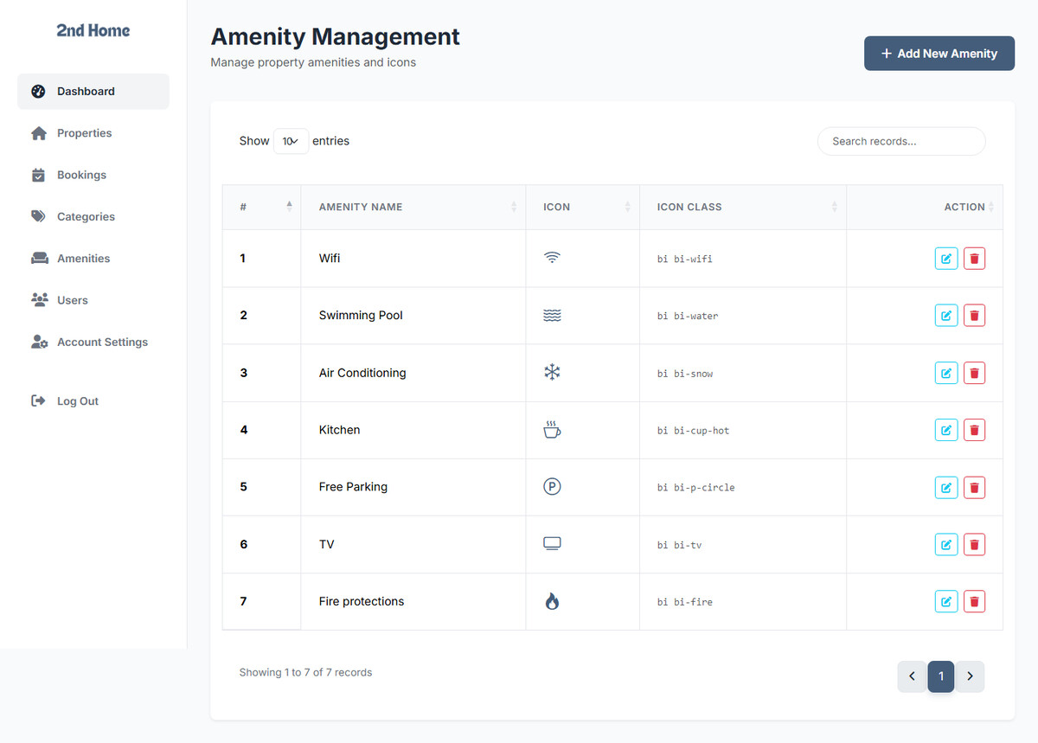
Figure 11.24 – Amenity list

11.25 Admin – User Management
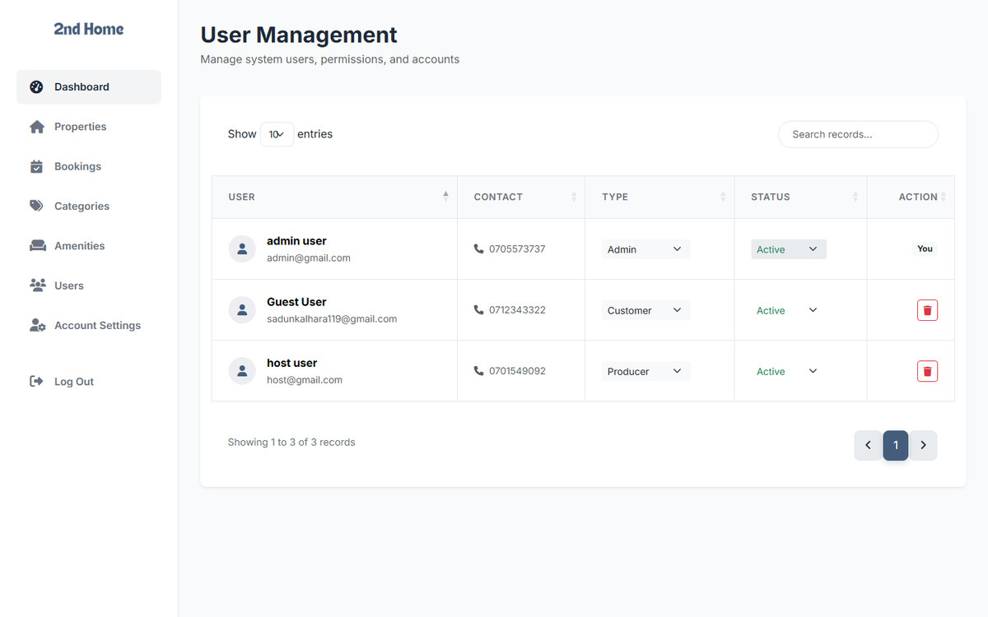
Figure 11.25 – User management (type and status)

11.26 XML Feed
Figure 11.26 – XML feed of the properties

11.27 XML Validation Result
Figure 11.27 – XML checked against the DTD

11.28 XML Feed Link in the Footer
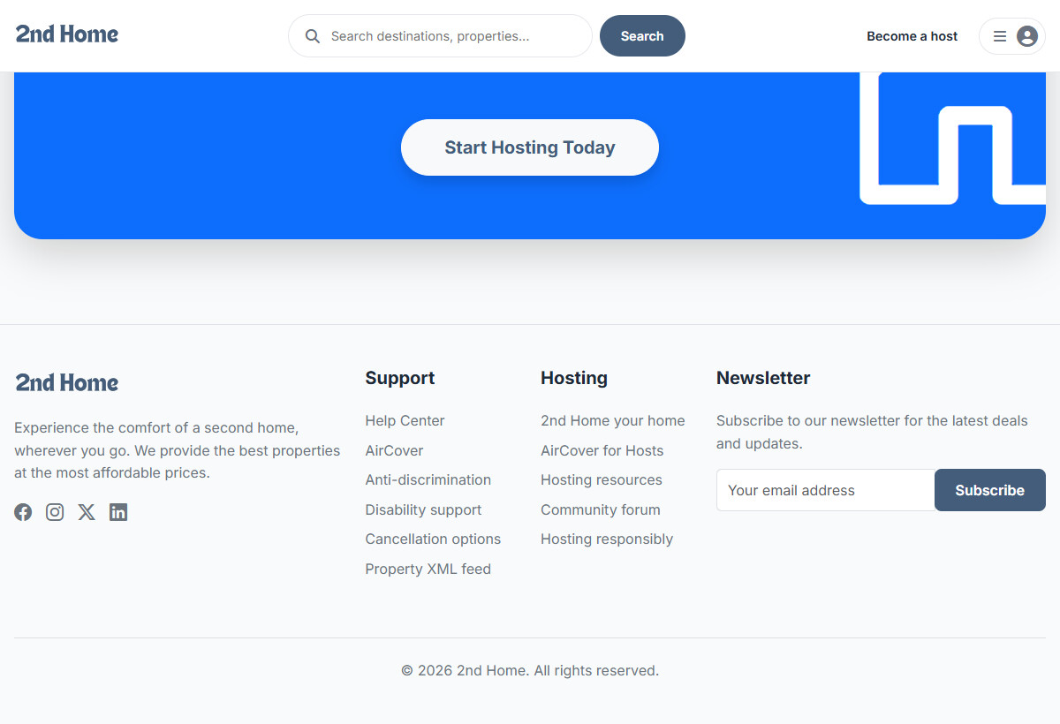
Figure 11.28 – Property XML feed link in the website footer

12. Conclusion
The 2nd Home web application has been designed and built successfully. It replaces phone calls and handwritten calendars with a fast, easy-to-use website that guests, hosts and administrators can use from any device.
What the system does
- Guests can search properties, check availability, book online and pay through PayHere with fully validated forms.
- Guests can use a booking cart for multi-checkout, save favourites and review the properties they have stayed in.
- Hosts can add, edit, activate and delete their own listings with photos, amenities and rich-text descriptions, and see their bookings.
- Administrators can manage properties, categories, amenities, users and bookings from one dashboard.
- Double bookings are prevented, prices are calculated on the server and every form is validated on both the browser and the server.
- Confirmation, cancellation, welcome and password-reset e-mails are sent automatically.
- An XML feed of the properties is published and checked against a DTD (properties-feed.php and xml/properties.dtd).
- The code is organised with reusable components, a Database class, a Validation class and a Mailer class.
- The interface is responsive and uses a consistent theme defined by CSS variables.
Future improvements
The system can be improved in the future by:
- Storing passwords as hashes with password_hash() / password_verify() instead of plain text, and removing the password from cookies and the session.
- Replacing escaped SQL strings with prepared statements (bind_param) for every query.
- Checking the user role inside every admin and host process file, and adding CSRF tokens to forms.
- Moving the database, SMTP and PayHere secrets out of the source code into environment variables.
- Completing PayHere payment verification with a notify URL, and building a mobile app that reads the XML feed.
- Adding host replies to reviews, a booking calendar view and online refunds.

Appendices

Project File Structure
onlinestore/
index.php Home page
search.php Search and category results
single-property.php Property details, availability, reviews
booking.php Confirm and pay
cart.php Booking cart (multi-checkout)
my-bookings.php Guest bookings (edit / cancel)
favorites.php Saved properties
account-settings.php Profile and password
signin.php signup.php logout.php
forgot-password.php reset-password.php
properties-feed.php XML feed of the properties
database.sql Database script
Dockerfile docker-compose.yml
admin/
dashboard.php Admin overview
user-management.php Users: type, status, delete
category/ list.php, add.php, edit.php
amenity/ list.php, add.php, edit.php
producer/
dashboard.php Host overview
listing/
list.php add.php edit.php bookings.php
components/
head.php NavigationBar.php Footer.php script.php
AdminSidebar.php ProducerSidebar.php FilterForm.php email.php
includes/
connection.php Database class
validation.php Validation class
mailer.php Mailer class (PHPMailer)
lib/ AJAX process files (*-process.php)
mail/ PHPMailer library
xml/
properties.dtd DTD rules for the XML feed
migrations/ SQL updates (cart, status, reviews)
assets/
css/ js/ libraries/
images/ banner categories logo properties slider

Database Schema
Table | Column | Type & Notes
user_types | id / name | INT PK AUTO / VARCHAR(50)
status | id / name | INT PK AUTO / VARCHAR(50)
users | id | INT, PK, AUTO – Primary key
users | fname, lname | VARCHAR(50) each
users | mobile | VARCHAR(20)
users | email | VARCHAR(100)
users | password | VARCHAR(255)
users | vcode | VARCHAR(255), NULL – password reset code
users | user_type_id / status_id | INT – links to user_types / status (default status 1)
categories | id, name, image | INT PK AUTO, VARCHAR(100), VARCHAR(255) image filename
amenities | id, name, icon_cls | INT PK AUTO, VARCHAR(100), VARCHAR(100) icon class
properties | id | INT, PK, AUTO – Primary key
properties | title | VARCHAR(255)
properties | categories_id | INT – links to categories.id
properties | description, address | TEXT
properties | guests, bedrooms, beds, bathrooms | INT
properties | images | TEXT – comma-separated photo file names
properties | base_price | DECIMAL(10,2) – price per night
properties | users_id / status_id | INT – host (users.id) / Active or Inactive
properties_has_amenities | properties_id, amenities_id | INT – composite primary key
bookings | id | INT, PK, AUTO – Primary key
bookings | checkIn, checkOut | DATE
bookings | first_name, last_name | VARCHAR(50)
bookings | nic, contact | VARCHAR(20)
bookings | guests, properties_id | INT – properties_id links to properties.id
bookings | email | VARCHAR(100)
bookings | special_requests | TEXT, NULL
bookings | total_price | DECIMAL(10,2)
bookings | order_id | VARCHAR(100) – PayHere order id
cart | id | INT, PK, AUTO – Primary key
cart | users_id, properties_id | INT, FK – ON DELETE CASCADE
cart | checkIn, checkOut, guests | DATE, DATE, INT
reviews | id | INT, PK, AUTO – Primary key
reviews | properties_id, users_id | INT, FK – ON DELETE CASCADE
reviews | rating | INT (1–5)
reviews | comment | TEXT
reviews | created_at | TIMESTAMP – default current time

Demo Log In Credentials
Accounts that exist in the development database:
Role | Email | Password
Administrator | admin@gmail.com | Password123
Host (Producer) | host@gmail.com | Password123

